# 6601 – Assignment 2: Probabilistic Modeling and Inference

Instructor: Thad Starner TA: Daniel Kohlsdorf, Titilayo Craig

Weiren Wang(903076444) weirenwang@gatech.edu

[](http://www.linkedin.com/in/weirenwang/)https://www.linkedin.com/in/weirenwang

[](https://github.com/JeffreyWeirenWang)https://github.com/JeffreyWeirenWang

## Warm Up: Modeling(20%)

## AIMA 14.11

1. From the description, the relational model can be conclude that the temperature T has the influence on both Gauge G and Gauge Faulty $F_{G}$. The Gauge Faulty has the influence on Gauge G. Both the Alarm Faulty $F_{A}$ and Gauge G impact the Alarm A. The Bayes Network is as follow.
2. b.The network is not a poly tree. Temperature has the impact on Gauge G and Gauge Faulty $F_{G}$. The Gauge Faulty $F_{G}$ has a further impact on Gauge G. The undirected graph is cyclic.
3. In the table, the x indicated the probability that the gauge give the correct

temperature when it is working, but y when it is faulty.

Conditional probability table associated with G.

|  |  |  |  |  |
| --- | --- | --- | --- | --- |
|  | $F_{G}$ ＝true(Faulty) | | $F_{G}$ ＝false(working) | |
| T=Normal | T=High | T=Normal | T=High |
| G=Normal | y | 1-y | x | 1-x |
| G=High | 1-y | y | 1-x | x |

1. The alarm works correctly unless it is faulty, in which case it never sounds.

Conditional probability table associated with A.

|  |  |  |  |  |
| --- | --- | --- | --- | --- |
|  | $F_{A}$ ＝true(Faulty) | | $F_{A}$ ＝false(Correctly) | |
| G=Normal | G=High | G=Normal | G=High |
| A=Not Sounds | 1 | 1 | 1 | 0 |
| A=Sounds | 0 | 0 | 0 | 1 |

1. From the description, we know that we are going to calculate the probability that the temperature is too high. The condition in above is the alarm sounds, the alarm is working and the gauge is working. The formula is $P(t|a,¬F_{A}, ¬F_{G})$. From the Alarm conditionaly probability model we could see that the gauge must be normal. The formula could be written in $P(t|a, g,¬F_{A}, ¬F_{G})$.

$P(t|a, g,¬F_{A}, ¬F_{G})$

= $\frac{P(t, a,g,¬F_{A},¬F_{G})}{P(a,g,¬F_{A},¬F_{G})}$

= $\frac{P\left(a | ¬F_{A}\right)P\left(¬F_{A}\right)P\left(g | ¬F_{G},t\right)P\left({¬F}_{G} | t\right)P(t)}{P\left(a | ¬F_{A}\right)P\left(¬F_{A}\right)P\left(g | ¬F_{G}\right)P\left(g | ¬F_{G}\right)}$

= $\frac{P\left(g | ¬F_{G},t\right)P\left({¬F}_{G} | t\right)P(t)}{P\left(g,¬F_{G},t\right)+P\left(g,¬F_{G},¬t\right)}$

= $\frac{P\left(g | ¬F_{G},t\right)P\left({¬F}_{G} | t\right)P(t)}{P\left(g | ¬F_{G},t\right)P\left(¬F_{G} | t\right)P\left(t\right)+P\left(g | ¬F_{G},¬t\right)P\left(¬F_{G} | ¬t\right)P\left(¬t\right)}$

## Practice: Inference (20%)

## AIMA 14.20

a. Gibbs sampling is a special case of Metropolis-Hastings algorithm. In Gibbs

sampling, instead of changing a vector in Metropolis-Hastings, it changes a specific

dimensional value.

$α\left(x^{'} | x\right)=\min\left(1, \frac{π\left(x^{'}\right)q\left(x | x^{'}\right)}{π\left(x\right)q\left(x^{'} | x\right)}\right)$ = $\min\left(1, \frac{π\left(x^{'}\right)p\left(x | x^{'}\right)}{π\left(x\right)p\left(x^{'} | x\right)}\right)$

= $\min\left(1, \frac{π\left(x^{'}\right)p\left(x^{'} | x\right)p(x)}{π\left(x\right)p\left(x^{'} | x\right)}\right)=1$

From the deduction, the $α\left(x^{'} | x\right)$ is always 1. Thus, the Methopolis-Hastings

always accept the sampling.

b. In the deduction below, we only decuct $P(x→x^{'})$ because the x and x’ are

symmetric. We could get another once one is valid.The transition probability

from $x$ to $x^{'}$ is $P(x→x^{'})$. The

$$P\left(x→x^{'}\right)= q(x^{'}|x)α(x^{'}|x)$$

Therefore

$$π\left(x\right)p\left(x→x^{'}\right)$$

$$= π\left(x\right)q\left(x^{'} | x\right)α\left(x^{'} | x\right)$$

$$= π\left(x\right)q\left(x^{'} | x\right) \frac{π\left(x^{'}\right)q\left(x | x^{'}\right)}{π\left(x\right)q\left(x^{'} | x\right)}$$

$=π\left(x^{'}\right)q\left(x | x^{'}\right)$ $=$ $π\left(x'\right)q\left(x | x^{'}\right)α\left(x | x^{'}\right)=$ $π\left(x^{'}\right)p\left(x^{'}→x\right)$

Hence, the two steps process is in detailed balance with $π$

## Implementation(60%)

## AIMA 14.21

a. In this relational probability model, we have three soccer teams (A, B, C).

Between each teams, there is a match(AB, AC, BC). The numerical values we

construct is as follows:

Domain

Team Name domain: $Team.Name∈\{A,B,C\}$

Team Quality domain: $Team.Quality∈\{0, 1, 2, 3\}$

Match Result domain: $Match.Result∈\{win, draw, lose\}$

Examples for above definition as follows:

A.Quality = 2 denotes team A’s quality is 2.

AB.Result = win denotes that Team A won Team B in the match.

Distribution:

For quality distribution in each team, we use uniform distribution.

Team.Quality.Distribution~<0.25, 0.25, 0.25, 0.25>

Match Result distribution should depends probabilistically on the differences on

team qualities. There are two different ways to set up the distribution.

Method 1:

AB.Result ~ < $0.3+0.1*\left(AQ-BQ\right), 0.4-{{\left(AQ-BQ\right)}^{2}}/{16}, 0.3+{{\left(AQ-BQ\right)}^{2}}/{16}-0.1*\left(AQ-BQ\right)$ >

In this distribution, large difference increase the win and lost probability while

small difference increase the tie probability.

Method 2:

AB.Result ~ <AQ>BQ, AQ=BQ, AQ<BQ>

In this distribution, the result is arbitrarily depend on the team quality. The

winner is the one who has a larger quality. Tie exists when two teams quality

are equal.

b. Each match between two teams are influenced by the two teams quality.

Therefore, the Bayesian Network as presented.

c. In the first two matches A beat B and drawn with C, then the posterior

distribution for the third match is: <code: bayesnet.m>

P(BC=’lose’| AB=’win’, AC=’draw’) = 0.5086

P(BC=’draw’| AB=’win’, AC=’draw’) = 0.2598

P(BC=’win’| AB=’win’, AC=’draw’) = 0.2316

d. The complexity is $O(2^{n})$. In this case, we know all matches results except the last

game. From all these games, we need to calculate the conditionally probability of

each team quality. For each team, there are 4 options and there are n teams. Thus

the complexity is $O(2^{n})$.

e. Gibbs Sampling Algorithm

Pseudo Code:

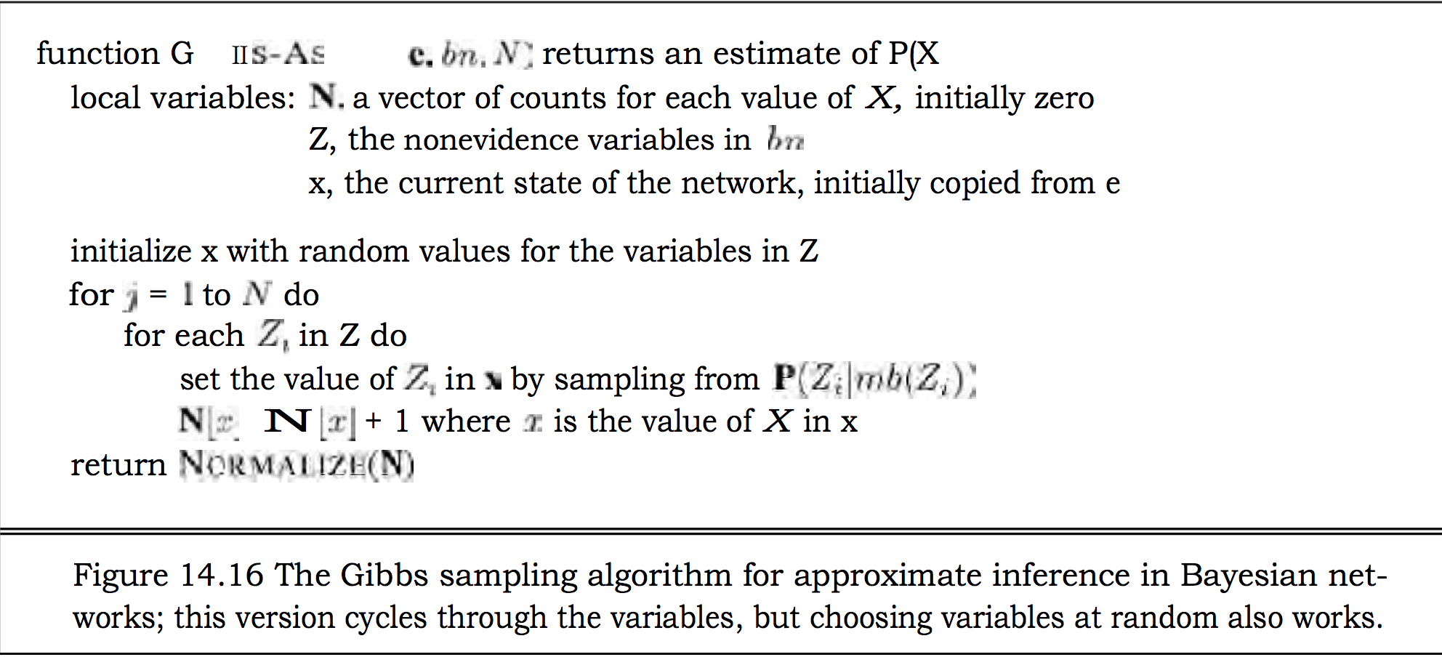

<code: gibbs.m>: Experiment data in chart below.

Gibbs Sampling Algorithm

|  |  |  |  |  |
| --- | --- | --- | --- | --- |
| Iterations Num | 10 | 1000 | 10000 | 100000 |
| P(BC=’lose’| AB=’win’, AC=’draw’) | 0.6000 | 0.3904 | 0.5035 | 0.5033 |
| P(BC=’draw’| AB=’win’, AC=’draw’) | 0.1000 | 0.2686 | 0.2715 | 0.2681 |
| P(BC=’win’| AB=’win’, AC=’draw’) | 0.3000 | 0.3410 | 0.2250 | 0.2286 |

<code: mh.m>: Experiment data in chart below.

Metropolis-Hasting Algorithm

|  |  |  |  |  |
| --- | --- | --- | --- | --- |
| Iterations Num | 10 | 1000 | 10000 | 100000 |
| P(BC=’lose’| AB=’win’, AC=’draw’) | 0.5000 | 0.4310 | 0.5127 | 0.5024 |
| P(BC=’draw’| AB=’win’, AC=’draw’) | 0.1000 | 0.2590 | 0.2594 | 0.2674 |
| P(BC=’win’| AB=’win’, AC=’draw’) | 0.4000 | 0.3100 | 0.2279 | 0.2301 |

In the Gibbs Sampling, after 10000 iterations, the probability value converge. In the Metropolis-Hasting algorithm, after 10000 times iterations, the probability almost converge. The Gibbs Sampling seems a little better than the Metropolis Hasting algorithm. In all of Gibbs Sampling, the probability value converge in 100000 iterations. However, there are 1 time in 10 tries that the Metropolis Hasting didn’t converge. The converge rate depends a lot on the transitional probability. The more unidirectional transition every time, the more converge steps it need. In the distribution

AB.Result ~ < $0.3+0.1*\left(AQ-BQ\right), 0.4-{{\left(AQ-BQ\right)}^{2}}/{16}, 0.3+{{\left(AQ-BQ\right)}^{2}}/{16}-0.1*\left(AQ-BQ\right)$ >

Because of the complexity of distribution and randomness of Metropolis-Hasting transition, the Gibbs Sampling is better.